

**TRIBHUVAN UNIVERSITY**

Institute of Science and Technology(IoST)

**National College of Computer Studies**

Paknajol, Kathmandu

**LAB REPORT ON**

**Introduction to Cloud Computing**

**Submitted by: Submitted to:**

Pramit Amatya Mr. Nabaraj Bahadur Negi

Csit 8th B (Lecturer)

Roll no: 14

|  |  |  |  |
| --- | --- | --- | --- |
| S.N. | Title | Date | Signature |
| 1 | Install VirtualBox and Set Up Workstations with different flavors of Linux or windows operating systems on top of windows 7,8, Or 10. |  |  |
| 2 | Find a Procedure to transfer files from one Virtual Machine to another. |  |  |
| 3 | Install a Single-Node Hadoop Cluster on Linux/Windows. |  |  |
| 4 | Write a Word Count Program to demonstrate the use of Map and Reduce tasks in Java. |  |  |
| 5 | Write a Multithreading Program in Java. |  |  |
| 6 | Creating a Linux/windows virtual machine in the Microsoft Azure. |  |  |
| 7 | Creating Web Apps and Using App Service Plans in Microsoft Azure. |  |  |
| 8 | Creating a Function App in Microsoft Azure. |  |  |
| 9 | Creating a Microsoft Azure SQL Database. |  |  |
| 10 | Manage and control your cloud costs with Azure Cost Management. |  |  |

**Lab 1: Install VirtualBox and Set Up Workstations with different flavors of Linux or windows operating systems on top of windows 7,8, Or 10.**

**Step 1: Download and Install VirtualBox**

* Go to the official VirtualBox website: <https://www.virtualbox.org>
* Click on **“Downloads”** and choose the installer for **Windows hosts**.
* Run the downloaded .exe file and follow the installation prompts:
* Once installed, launch **VirtualBox**.

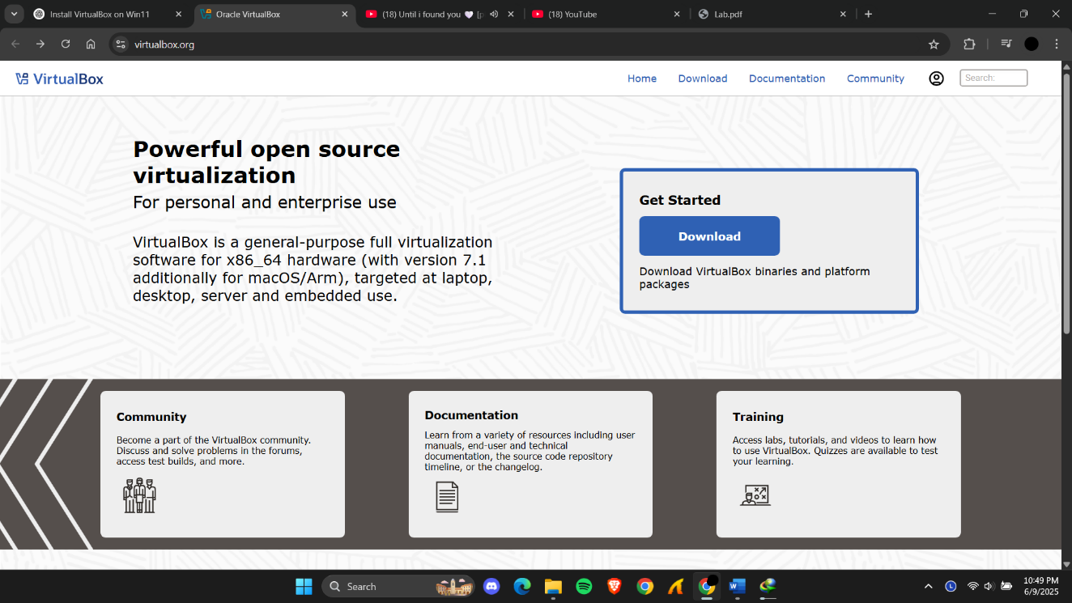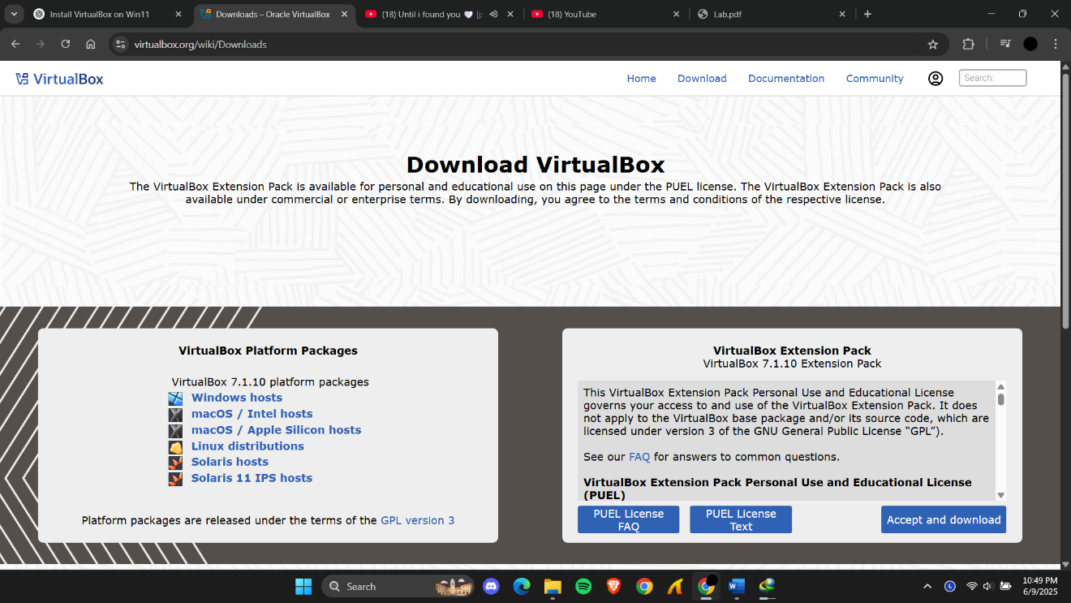

Step 2: Download ISO Files for Guest Operating Systems (I have used the kali Linux)

* + Download Kali Linux VirtualBox Image (https:/[/www.kali.org/get-kali/#kali-virtual-](http://www.kali.org/get-kali/#kali-virtual-) machines)
* Extract the file

**Step 3: Import Kali Linux into VirtualBox**

* Open Virtual Box > Machine > Add > Browse to the folder where the .vbox file is located
* Then Select file kali-linux-2025.1c-virtualbox-amd64.vbox and click open

Then Kali Linux will appear in the list of virtual Machines on the left side.

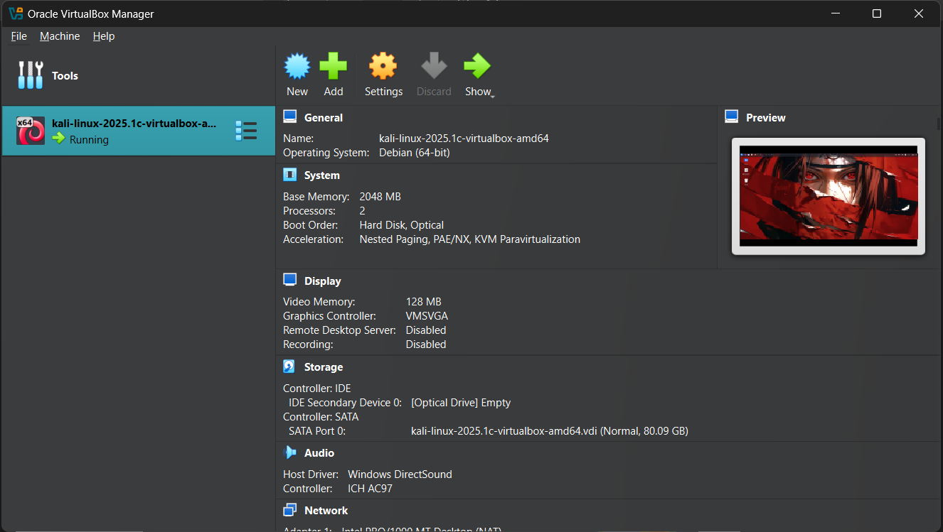

Step 4: Start the Virtual Machine

* + Select Kali Linux in VirtualBox
  + Click Start.
  + Use login Credentials and enjoy using kali Linux in virtualBox

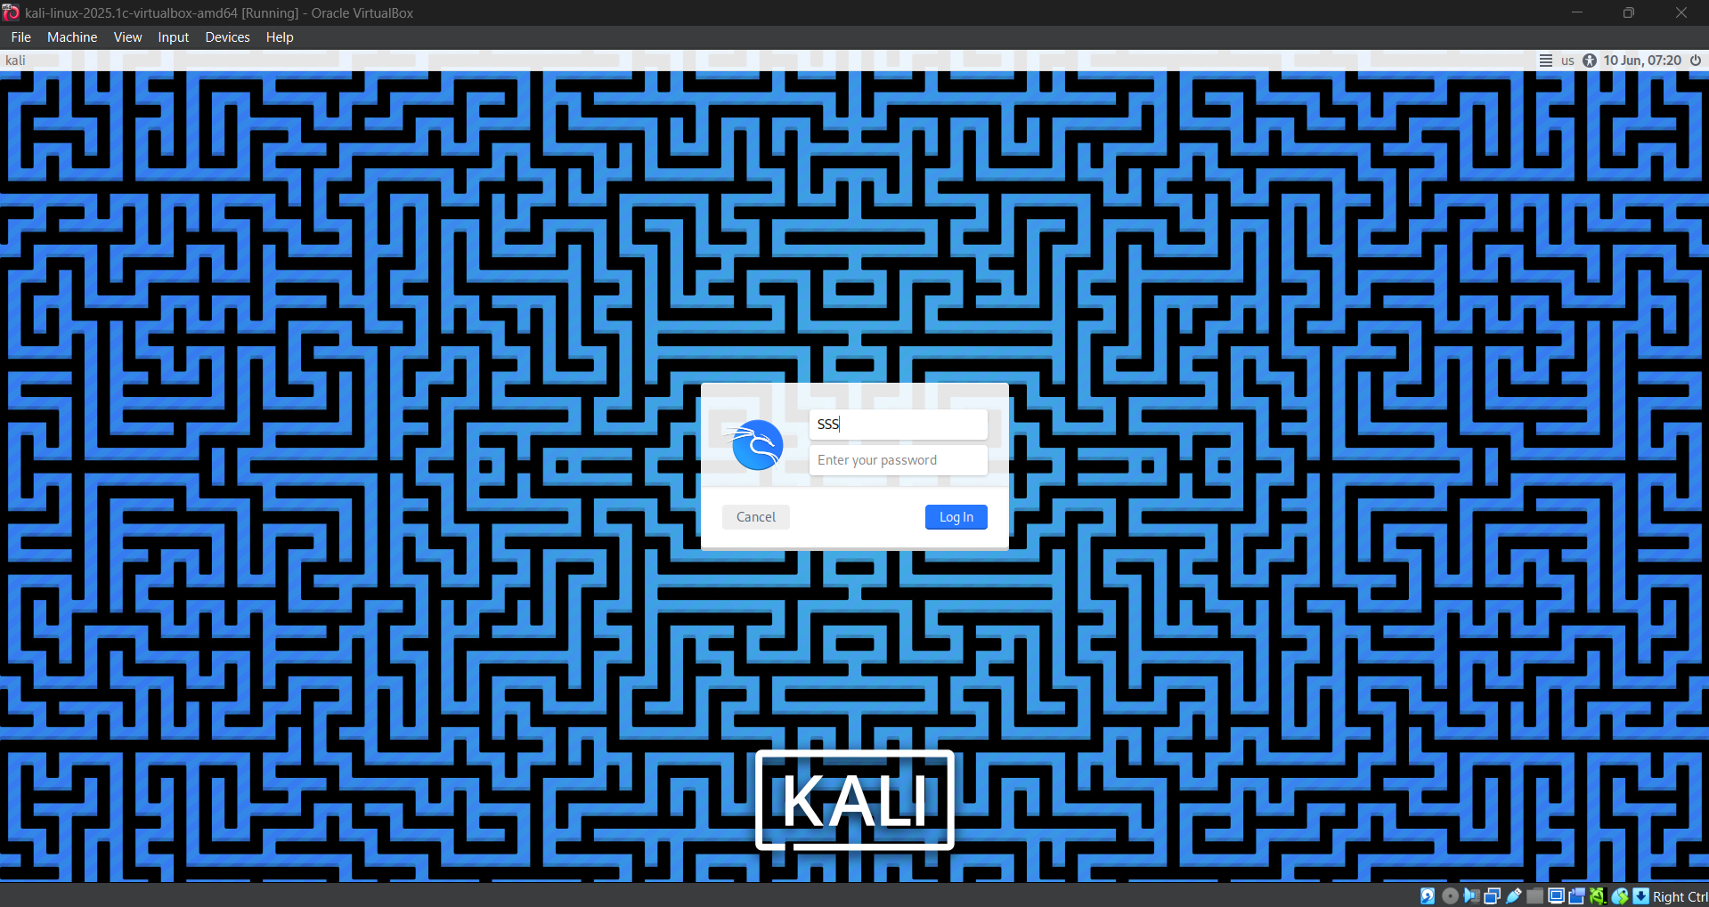

**Conclusion**

In this lab, we installed VirtualBox and created a kali Linux virtual machine. We learned how to configure VM settings, load the ISO, and start the installation. This lab showed how virtualization allows running multiple operating systems on one computer, which is useful for testing and learning.

**Lab 2: Find a Procedure to transfer files from one Virtual Machine to another.**

For this lab I have used two virtual machines kali Linux and Linux Mint.

Step 1: Power Off the Virtual Machines

* + Shut down both Kali Linux and Linux Mint virtual machines.

Step 2: Setup Shared Folder in VirtualBox

* + Open **VirtualBox**.
  + Select the Kali Linux VM
  + Click on **Settings > Shared Folders > + (Add New Shared Folder).**
  + Configure as follows:
    - **Folder Path**: Select a folder on your host system
    - **Folder Name**: Give it a name.( virtualbox_commeon_folder)
    - Check Auto Mount
  + Click ok

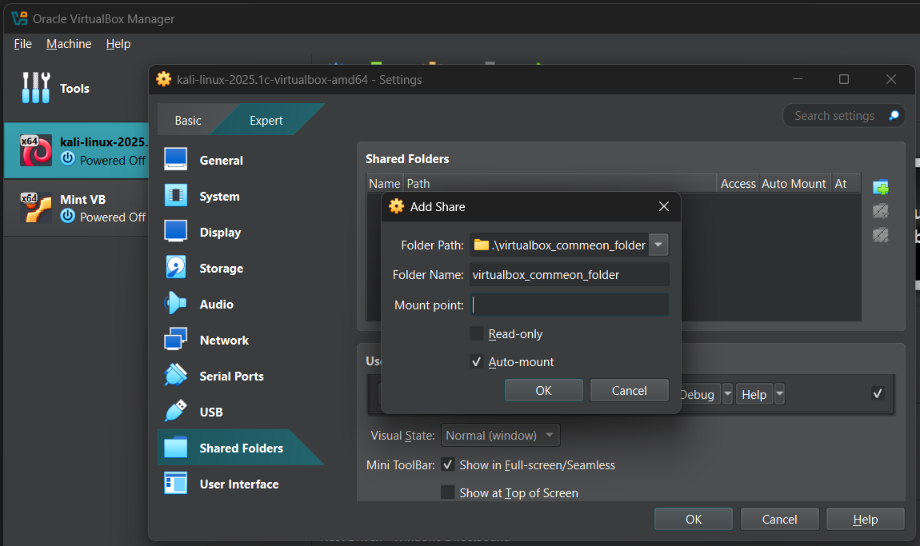

Step 3: Repeat for Linux Mint

* + Perform the same steps for the Linux Mint VM, selecting the same shared folder path and name.

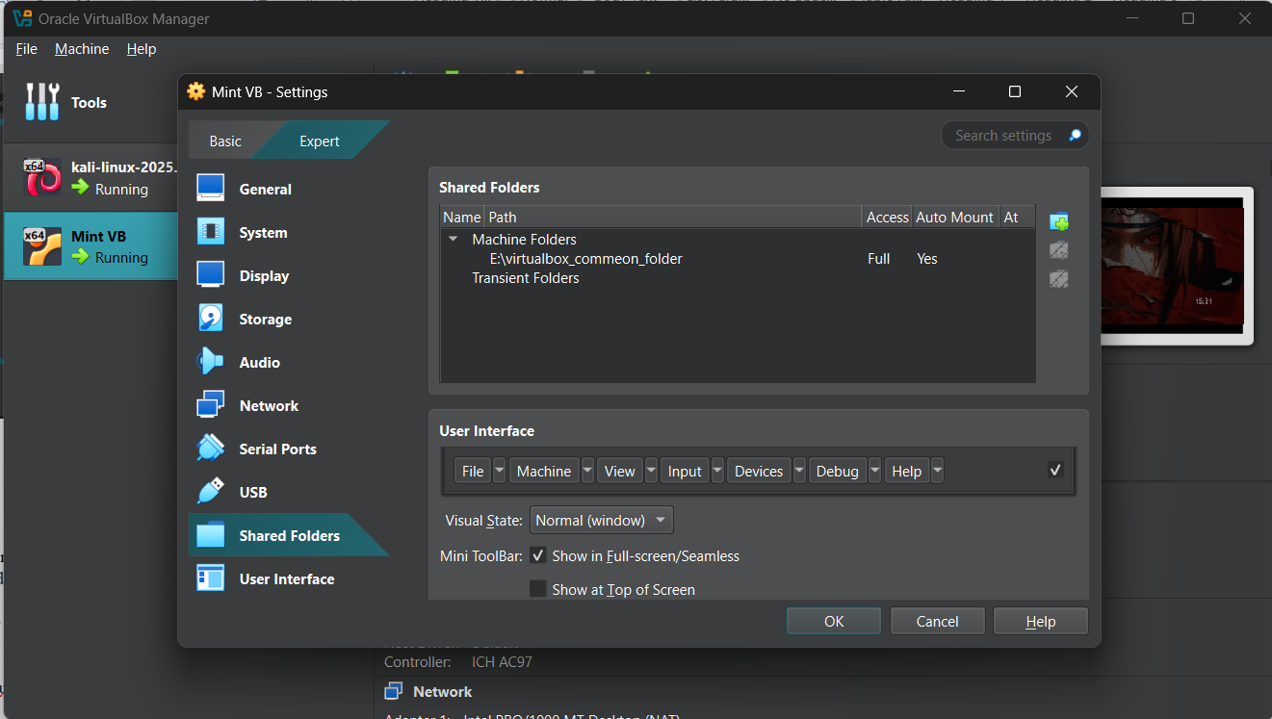

Step 4: Start the Virtual Machines

* + Boot up Kali Linux and Linux Mint one by one.

Step 5: Install Guest Additions (If Needed)

* + Run this on bothVMs:
* sudo apt update
* sudo apt install virtualbox-guest-utils

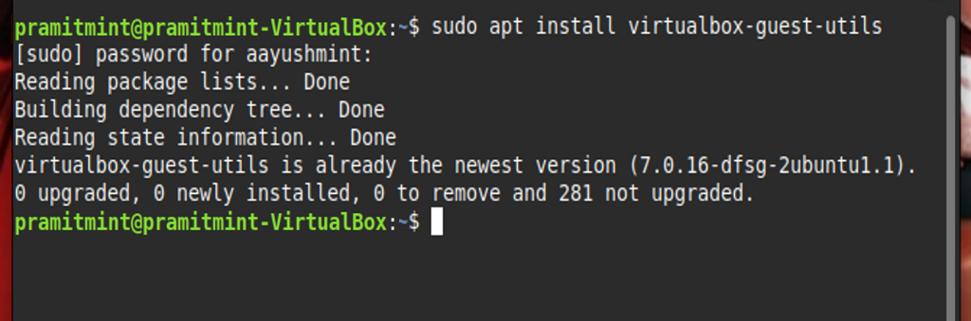

(OR)

* + In virtual Box > Devices > Insert Guest Additions CD image.

Step 6: Add User to vboxsf Group

* + On both VMs, run:
* sudo usermod -aG vboxsf $USER

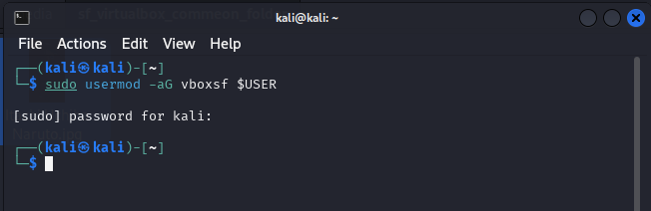

* + Then reboot VM: - reboot

Step 7: Access the Shared Folder via File Explorer

On both Kali Linux and Linux Mint:

* + Open the File Manager.
  + Navigate to: “/media/sf_virtualbox_commeon_folder”.

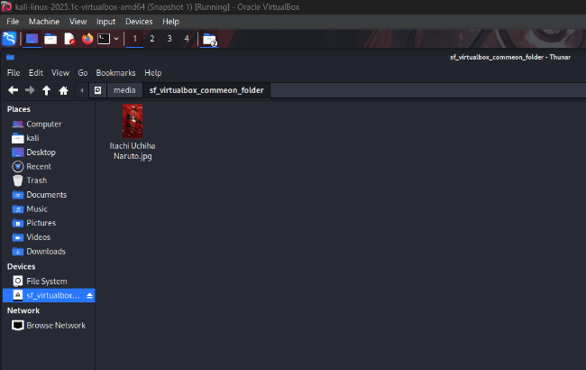

* + You can now drag and drop files to share between the two VMs.

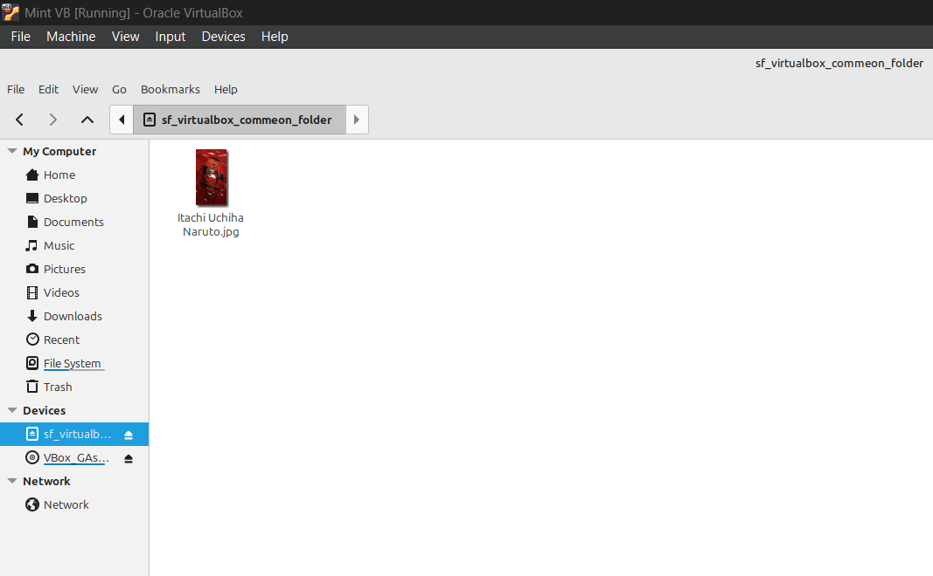

**Conclusion**

This lab demonstrated how to transfer files between Kali Linux and Linux Mint using a shared folder in VirtualBox. By configuring shared folder settings, installing Guest Additions, and setting correct permissions, we enabled simple and efficient file sharing between the two VMs without using external devices or network setups

**Lab 3: Install a Single-Node Hadoop Cluster on Linux/Windows.**

Step 1: Install Java

* sudo apt update
* sudo apt install openjdk-11-jdk -y

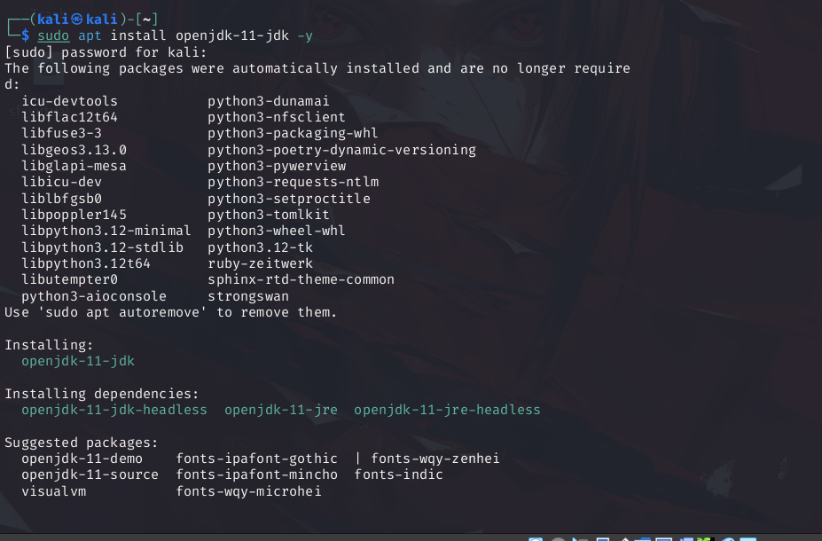

Step 2: Create Hadoop User

* sudo adduser hadoopuser
* sudo usermod -aG sudo hadoopuser
* su – hadoopuser

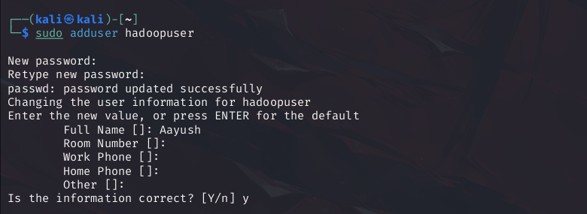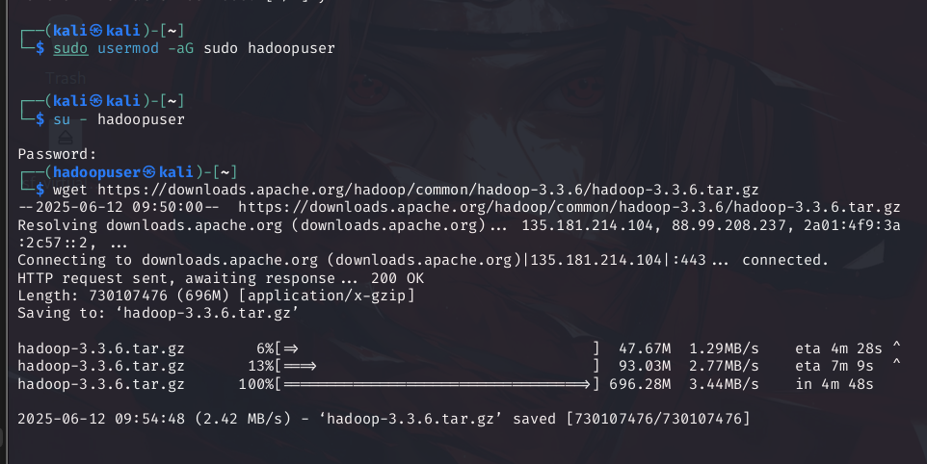

Step 3: Download and Extract Hadoop

* wget https://downloads.apache.org/hadoop/common/hadoop-3.3.6/hadoop-3.3.6.tar.gz
* tar -xvzf hadoop-3.3.6.tar.gz
* mv hadoop-3.3.6 ~/Hadoop



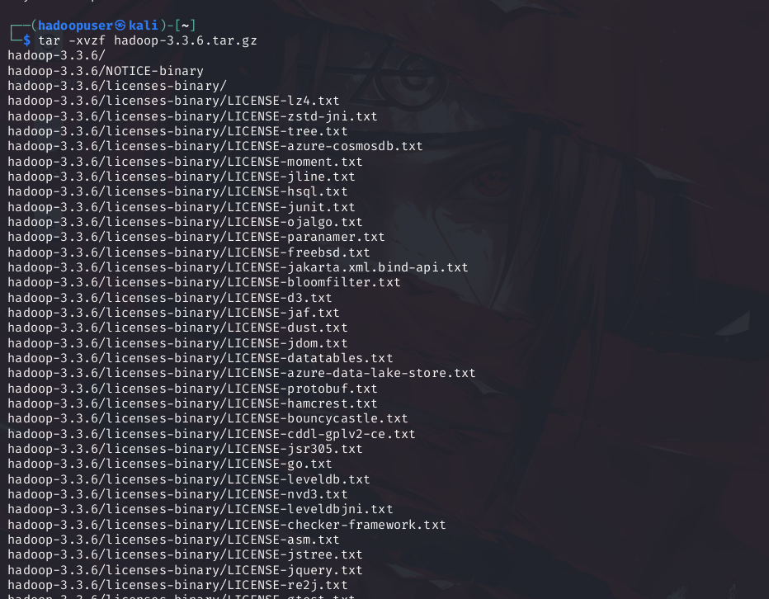

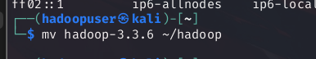

Step 4: Configure Environment Variables

* + Edit ~/.bashrc:
* nano ~/.bashrc

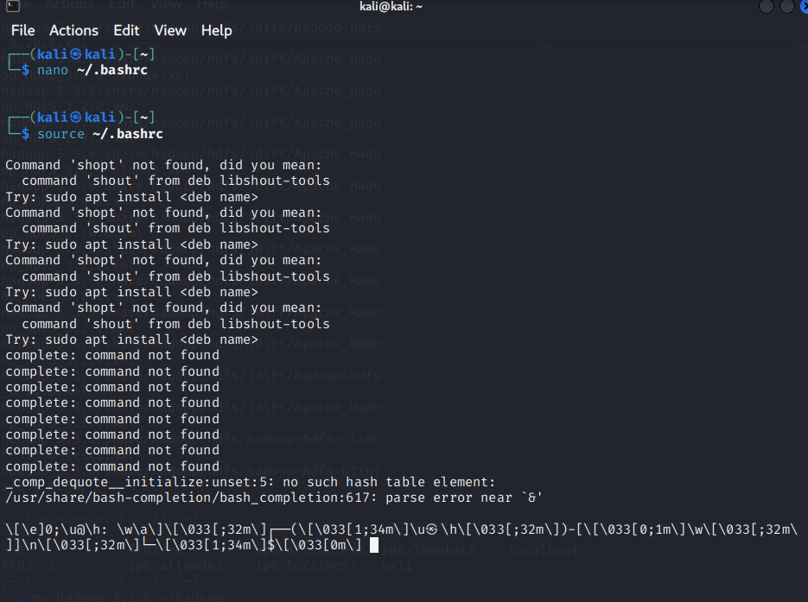

* + Add at the end then save and exit.

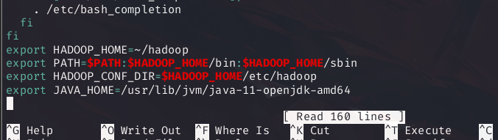

* + Create .bash_profile to source .bashrc:

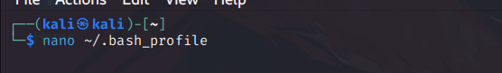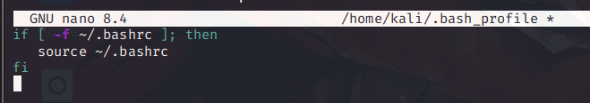

* + Apply changes:

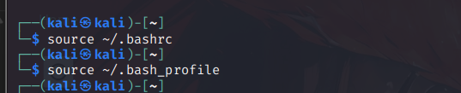

Step 5: Verify Hadoop Environment

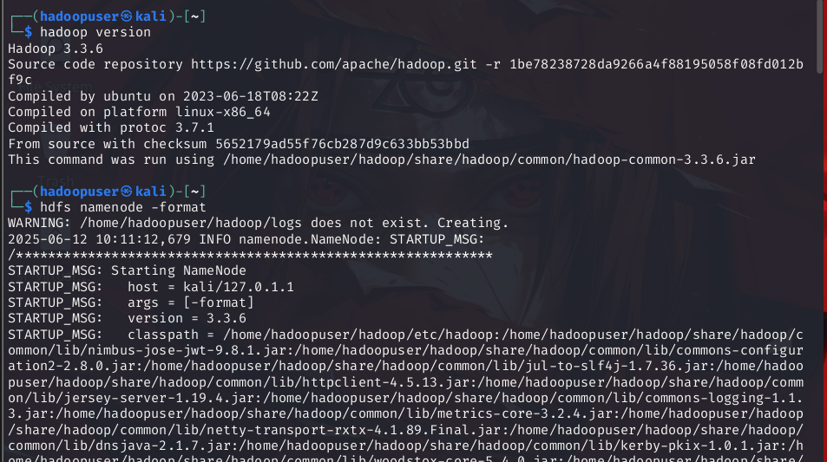

Step 6: Format the Hadoop Filesystem

* hdfs namenode -format



Step 7: Install OpenSSH Server and Enable It

* sudo apt install openssh-server -y
* sudo systemctl enable ssh
* sudo systemctl start ssh

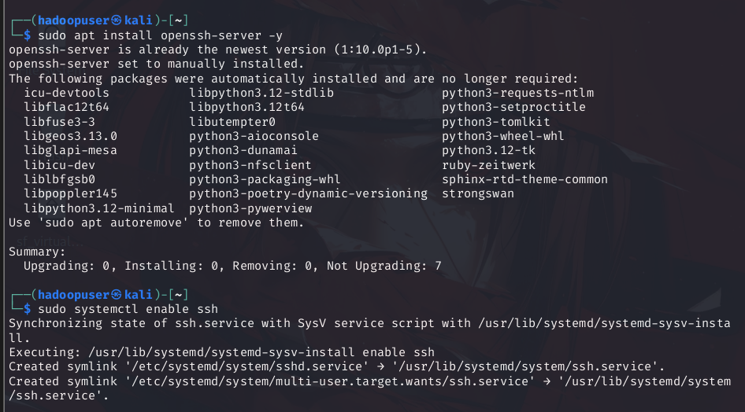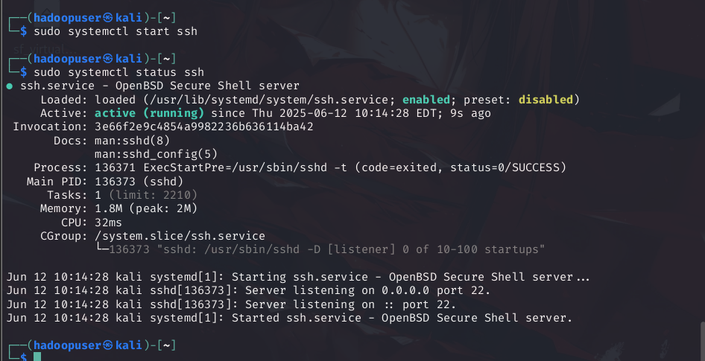

* + Verify SSH is running:



Step 7: Set Up SSH Passwordless Login for Hadoop User

* ssh-keygen -t rsa -P "" -f ~/.ssh/id_rsa
* cat ~/.ssh/id_rsa.pub >> ~/.ssh/authorized_keys
* chmod 600 ~/.ssh/authorized_keys
* chmod 700 ~/.ssh
* ssh localhost

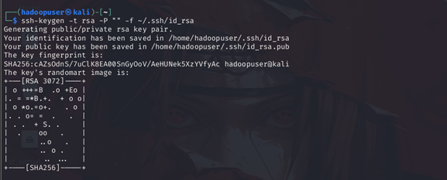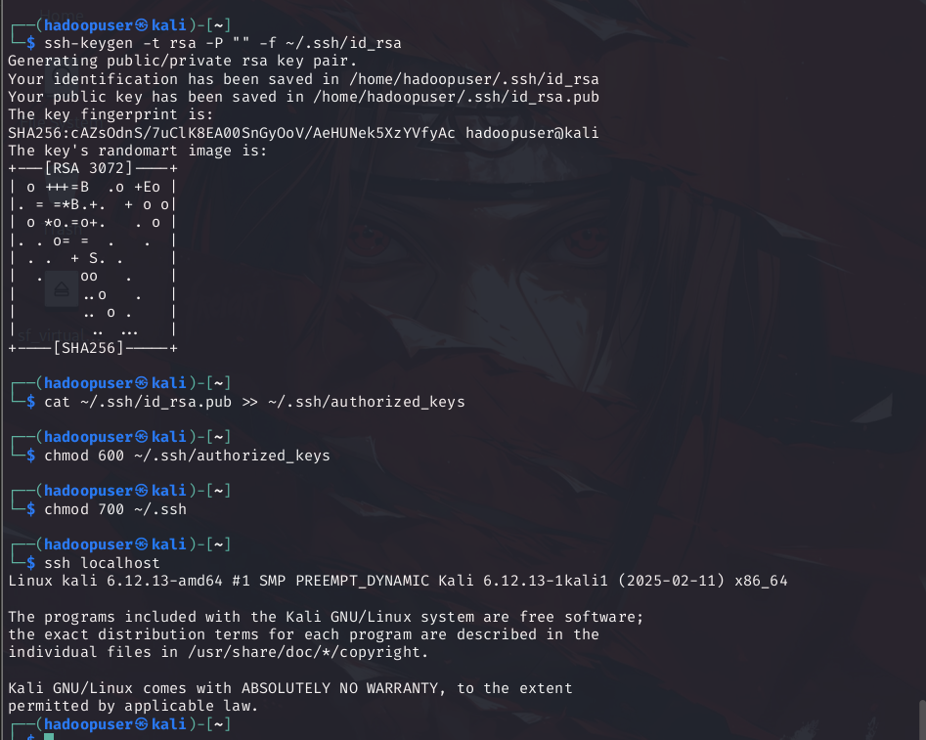

Step 8: Format Hadoop FileSystem

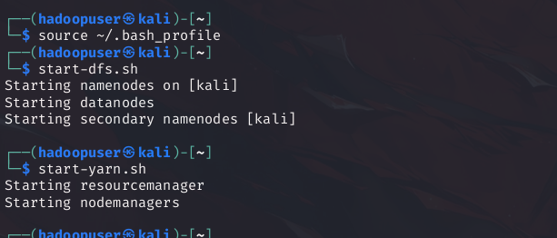

Step 9: Start Hadoop Services

* start-dfs.sh
* start-yarn.sh

Step 10: Verify Hadoop Daemons are Running

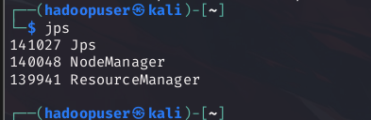

**Lab 4: Write a Word Count Program to demonstrate the use of Map and Reduce tasks in Java.**

Step 1: Login as hadoop user.

Step 2: Create directory

* mkdir wordcount
* cd wordcount



Step 3: Write java code:

* nano WordCount.java

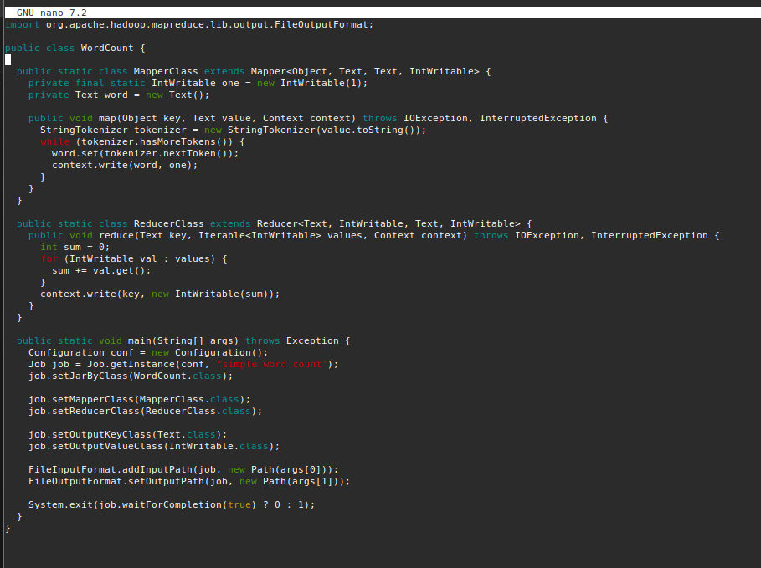

Step 4: Compile the code

* javac -classpath `hadoop classpath` -d . WordCount.java

Step 5: Create JAR file

* jar -cvf wordcount.jar *.class

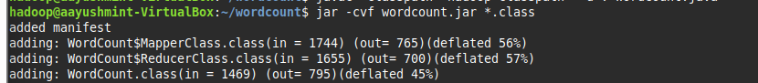

Step 6: Create input file.



Step 7: Create input directory

* HDFS. hdfs dfs -mkdir -p /user/$(whoami)/input

Step 8: Put file into HDFS

* hdfs dfs -put input.txt /user/$(whoami)/input

Step 9: Run code

* hadoop jar wordcount.jar WordCount /user/$(whoami)/input user/$(whoami) /output

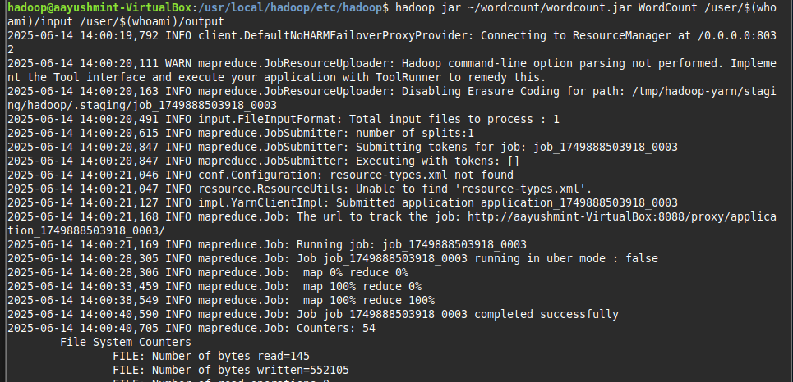

Step 10: Check result

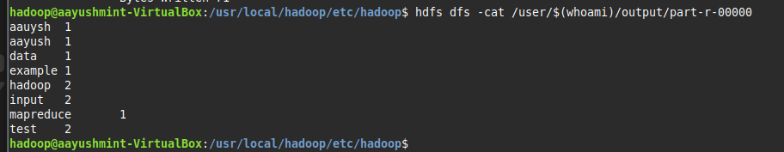

**Conclusion**

The WordCount program helped us understand how Hadoop breaks big tasks into smaller ones using Mapper and Reducer. It showed how large amounts of data can be processed step by step in a smart and organized way. This gave us a basic idea of how big data is handled in real-world systems using distributed computing.

**Lab 5: Write a Multithreading Program in Java.**

**Source Code:**

class MyThread extends Thread {

    private String threadName;

    MyThread(String name) {

        threadName = name;

    }

    public void run() {

        for (int i = 1; i <= 3; i++) {

            System.out.println(threadName + " - Count: " + i);

            try {

                Thread.sleep(500);

            } catch (InterruptedException e) {

                System.out.println(threadName + " was interrupted.");

            }

        }

        System.out.println(threadName + " has finished.");

    }

}

public class MultithreadExample {

    public static void main(String[] args) {

        MyThread t1 = new MyThread("Thread-1");

        MyThread t2 = new MyThread("Thread-2");

        t1.start();

        t2.start();

    }

}

**Output:**

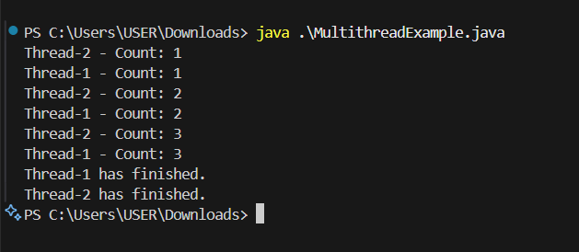

**Lab 6- Creating a Linux/windows virtual machine in the Microsoft Azure.**

1. Enter virtual machines in the search.
2. Under **Services**, select **Virtual machines**.
3. In the **Virtual machines** page, select **Create** and then **Virtual machine**.

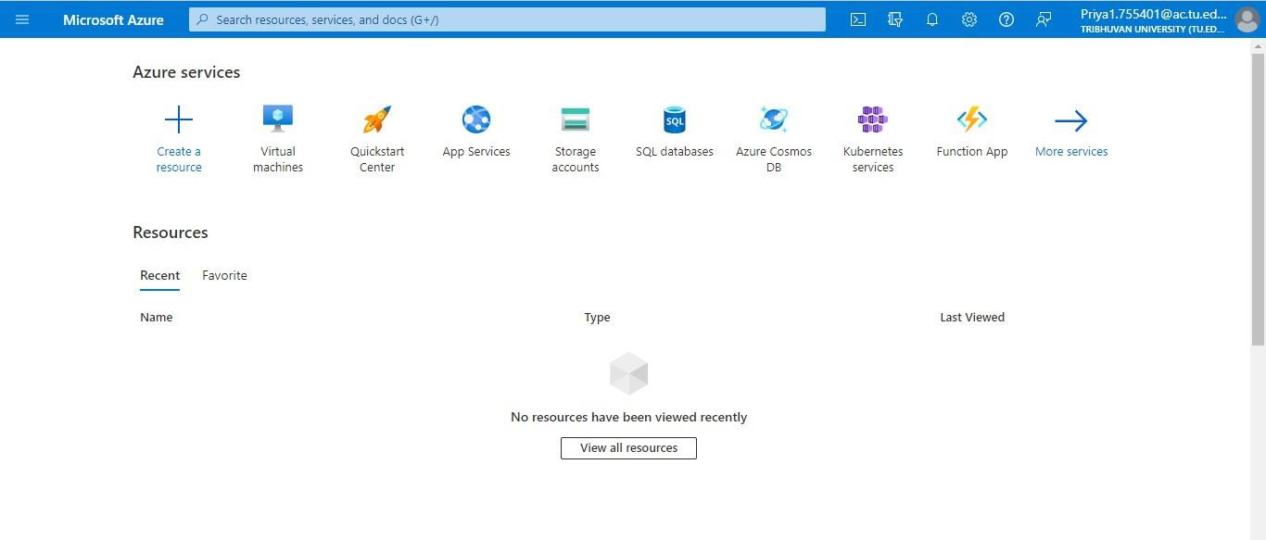

1. 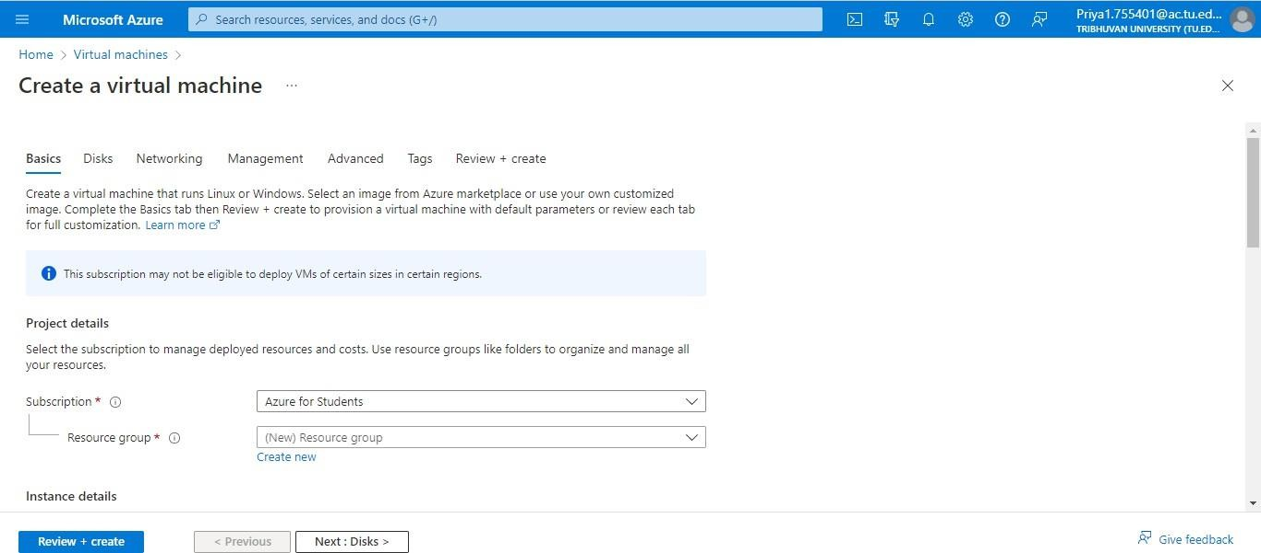In the **Basics** tab, under **Project details**, make sure the correct subscription is selected and then choose to **Create new** resource group.
2. Under **Instance details**, enter ClouPC for the **Virtual machine name**, and choose Ubuntu Server 20.04 LTS - Gen2 for your **Image**. Leave the other defaults. The default size and pricing is only shown as an example.

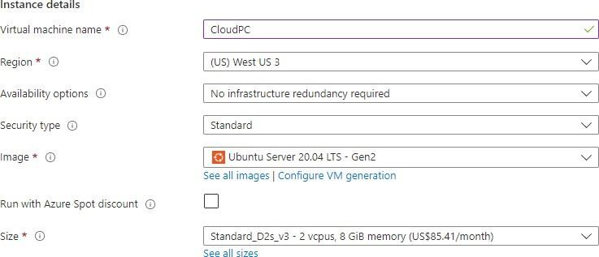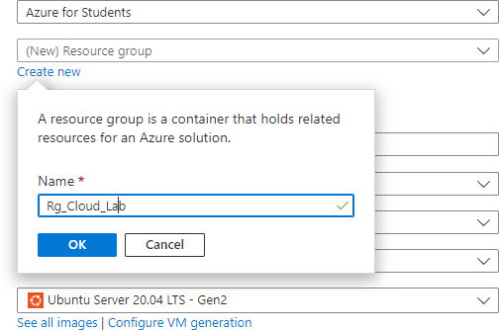

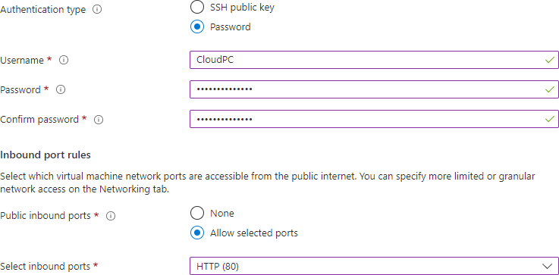

**Set up User name of your machine and password**

1. Prepare for the new Disk as:

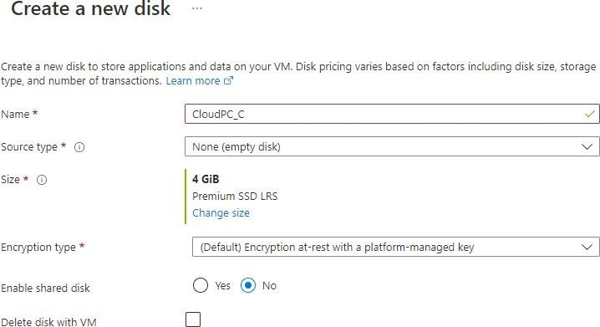

1. Select a disk Size from the window.

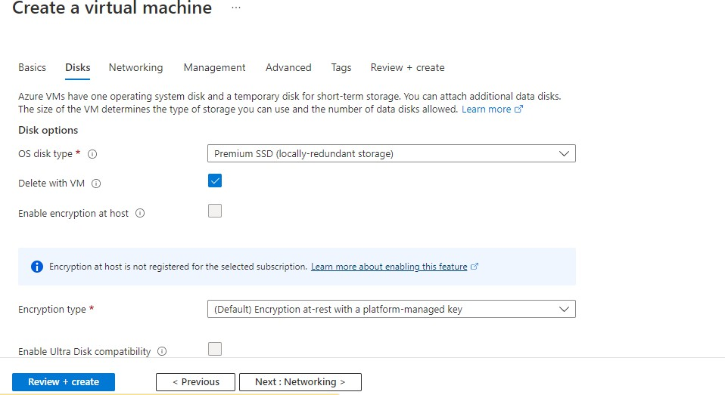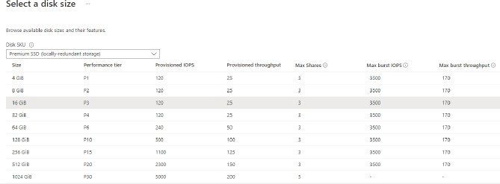

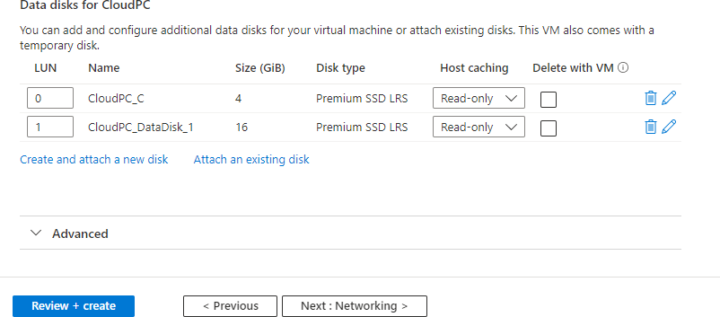

1. 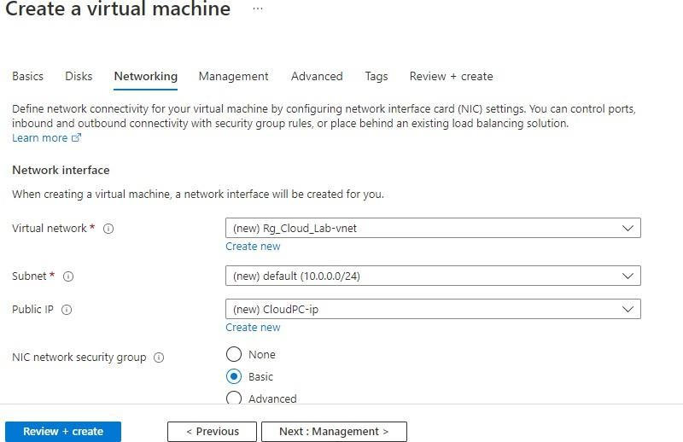Define network connectivity.
2. 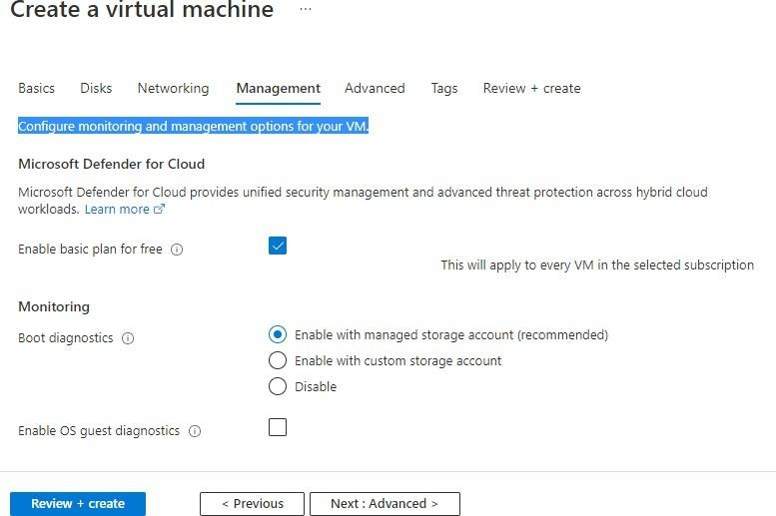Configure monitoring and management options for your VM.
3. Finally Review the Virtual machine.

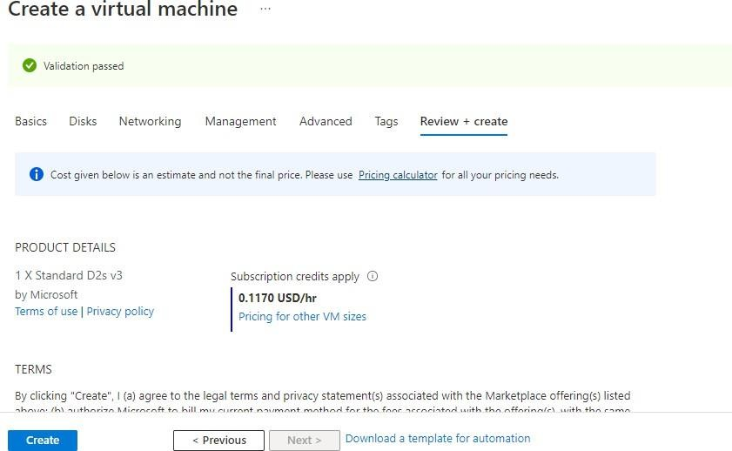

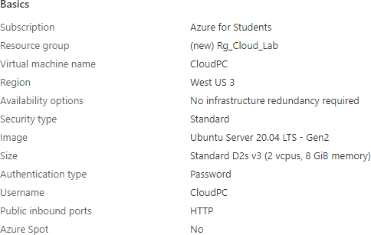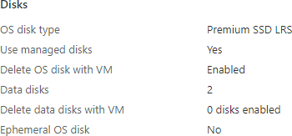

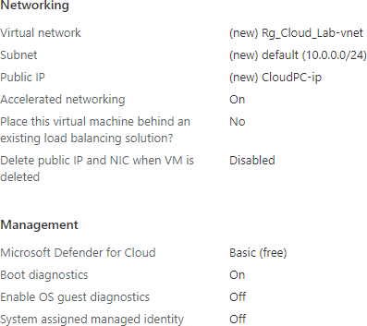

**Click on Create Button.**

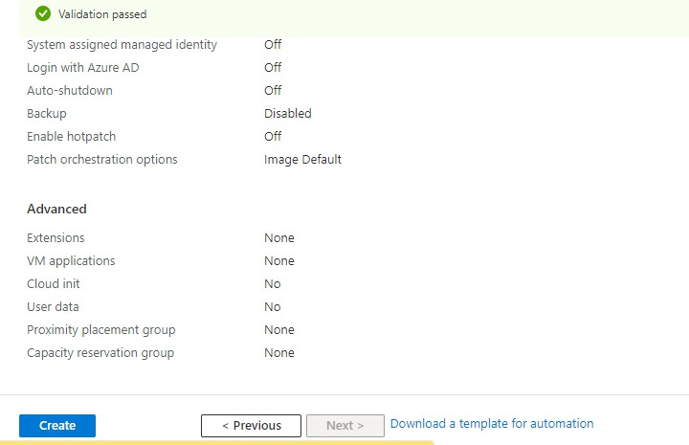

**Click on Go to Resource Button to view our VM Details**

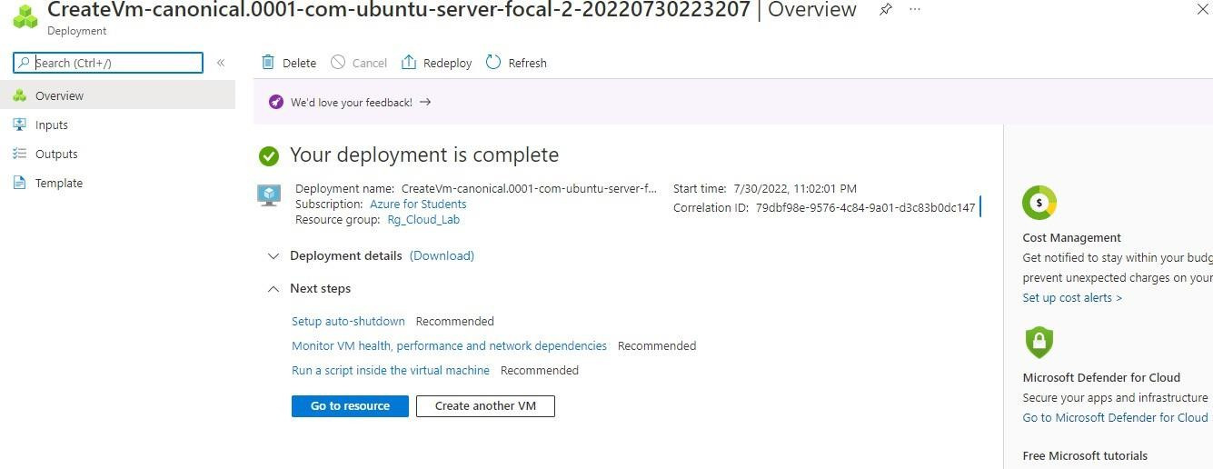

**To connect this VM to Remote Desktop, click in connect menu.**

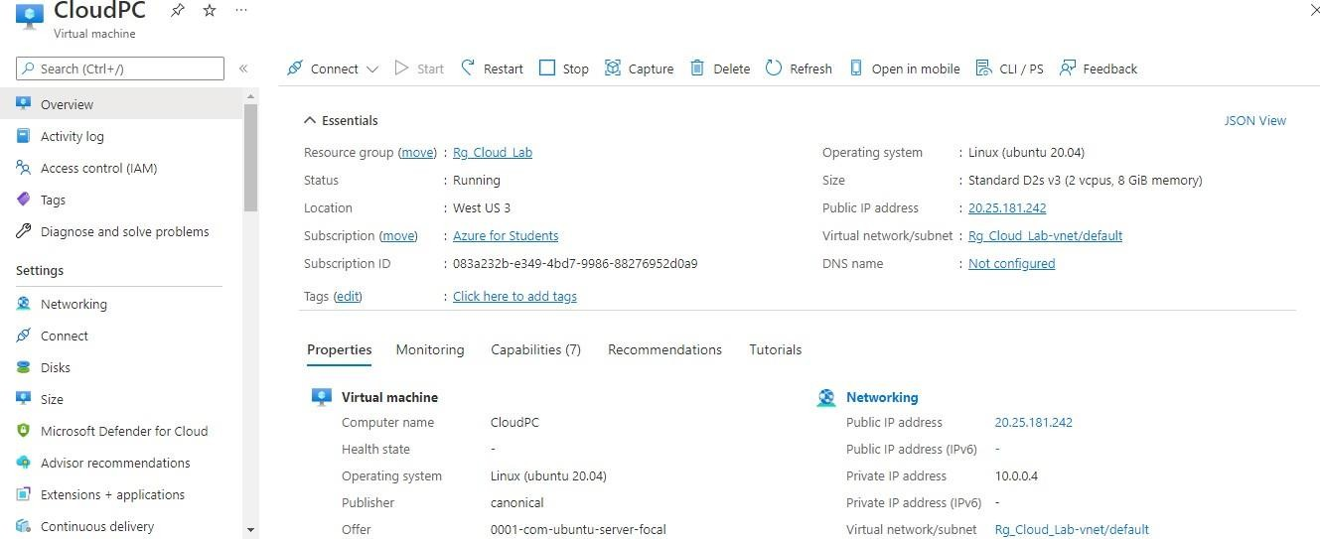

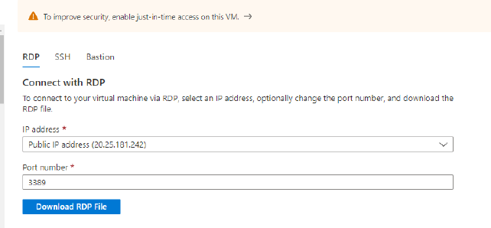

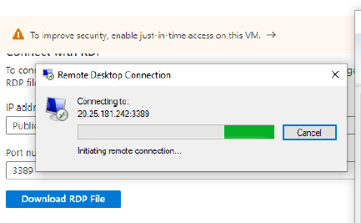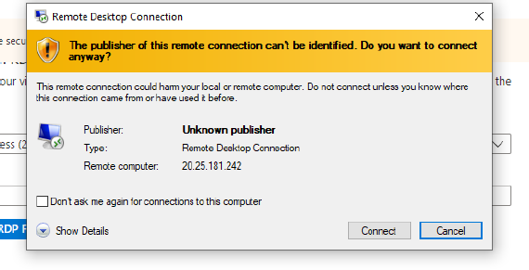

**Lab 7- Creating Web Apps and Using App Service Plans in Microsoft Azure.**

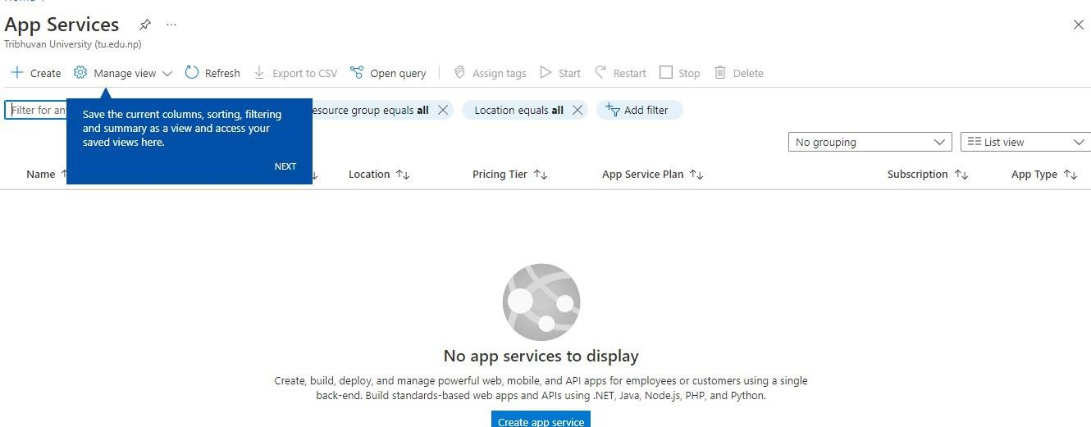

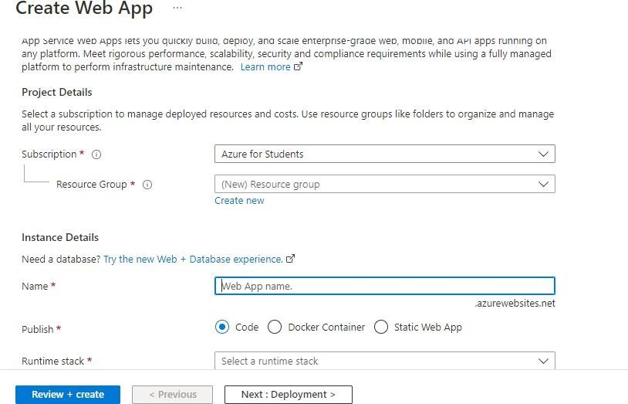

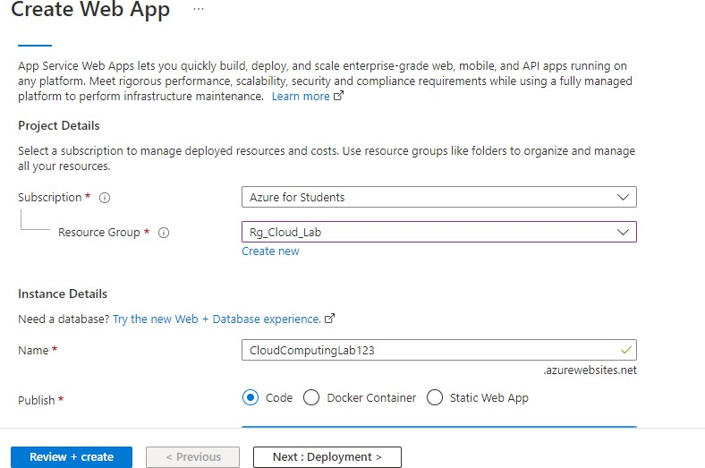

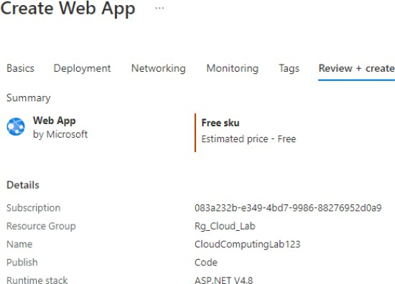

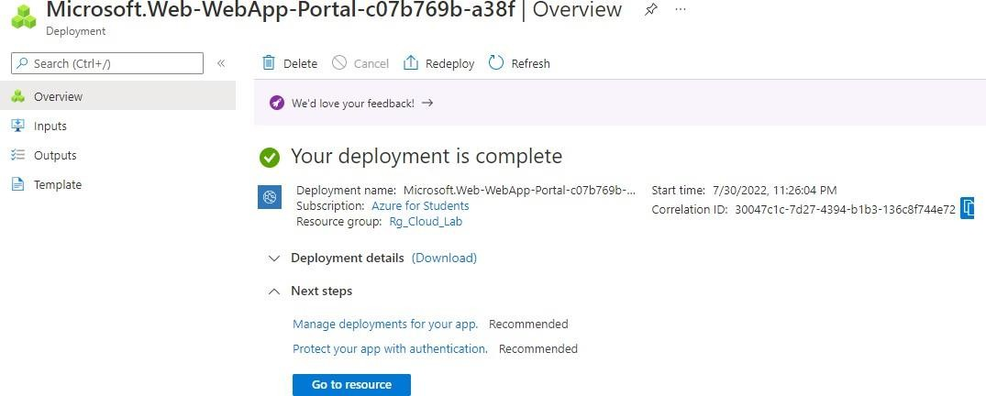

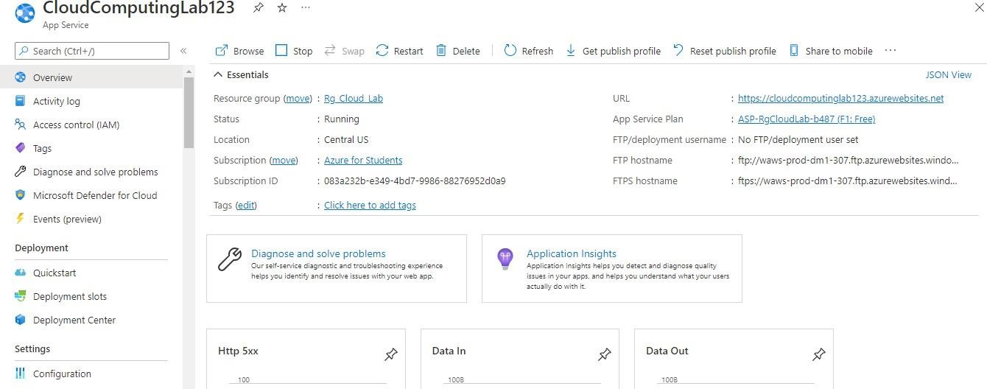

**Open Visual Studio and Create Project on ASP.NET Core Web App**

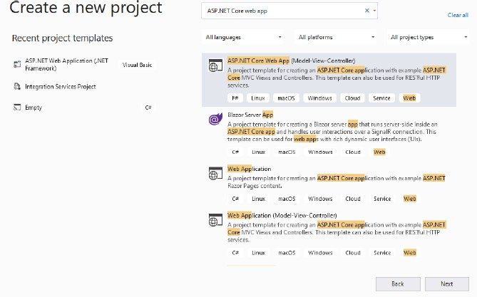

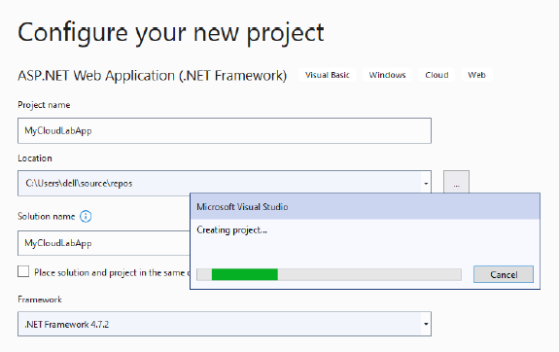

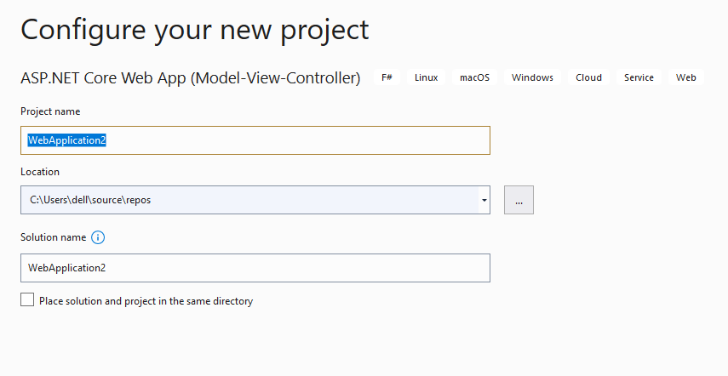

**Click on Connected Services option in Solution Explorer:**

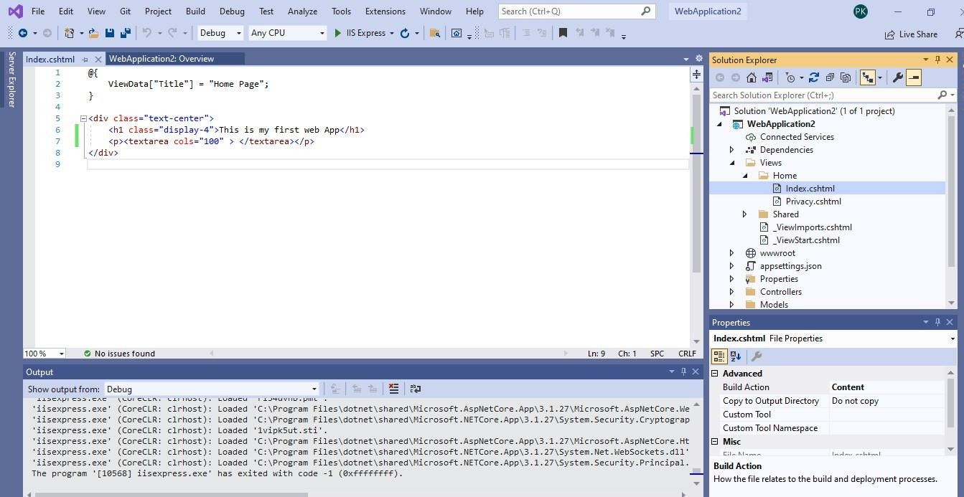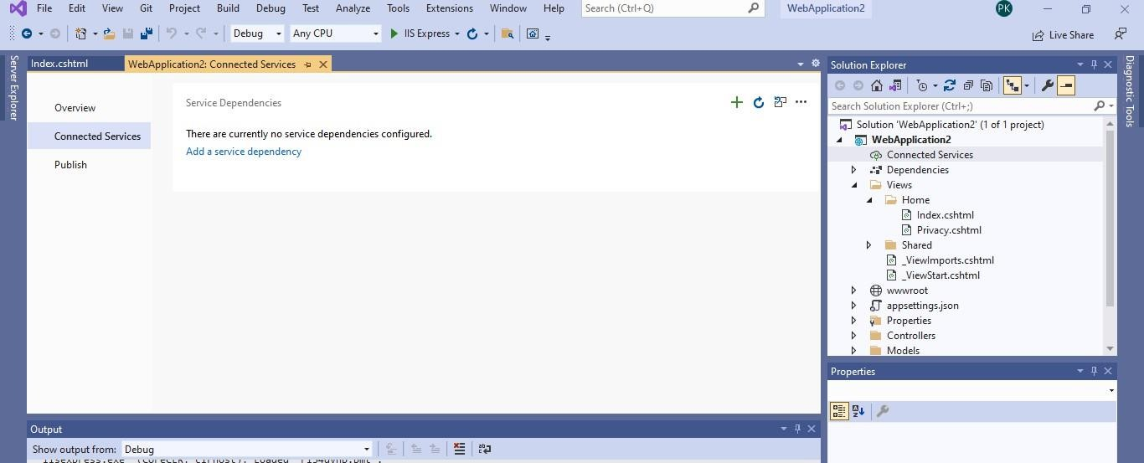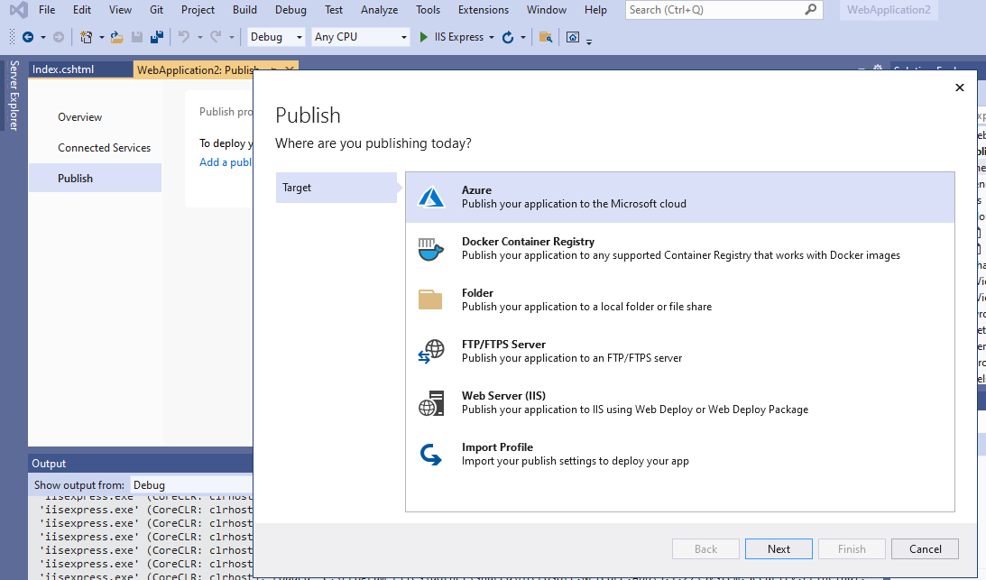

Select Azure

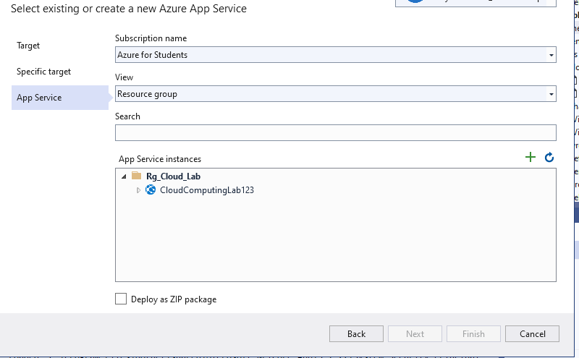

Choose Resource group and Web Site which is create in azure App service

**Click on Publish button to host our App:**

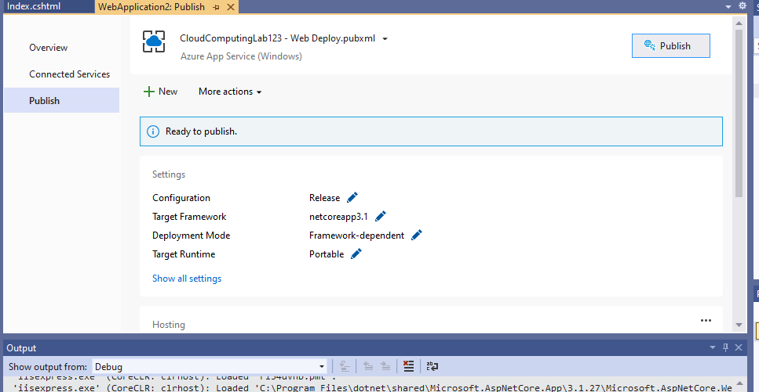

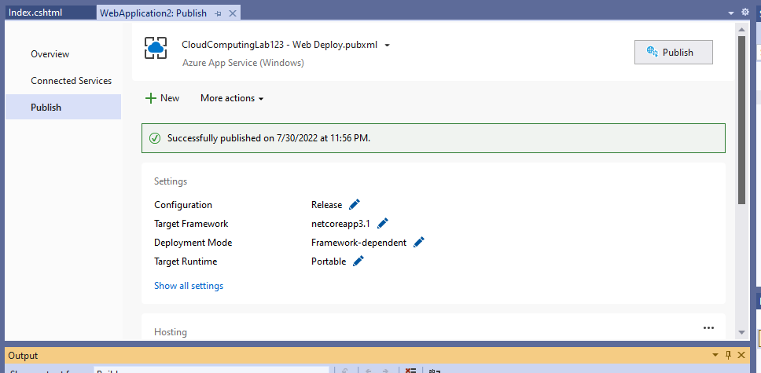

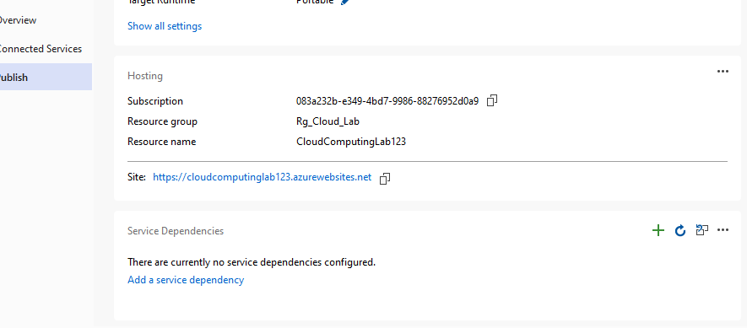

**After Clicking Our Site, Our Web App will be Displayed in browser.**

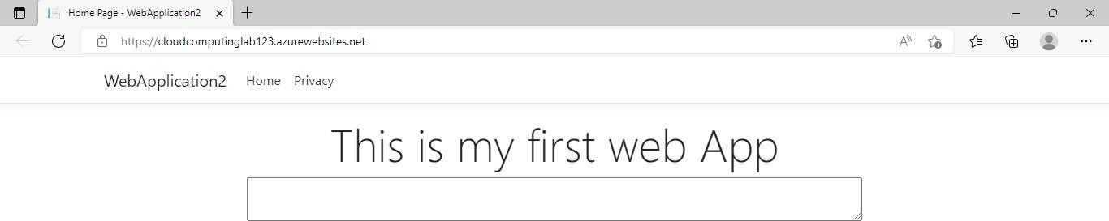

**Lab 8- Creating a Function App in Microsoft Azure.**

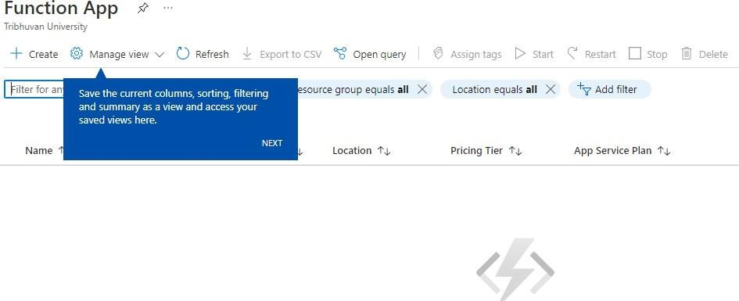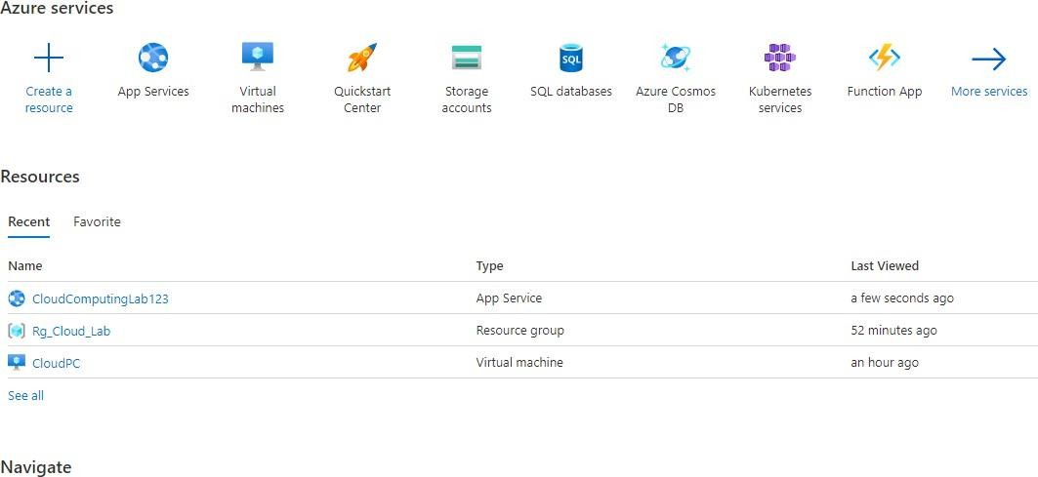

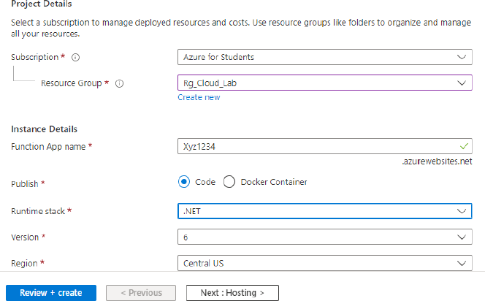

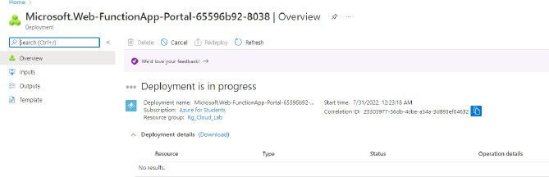

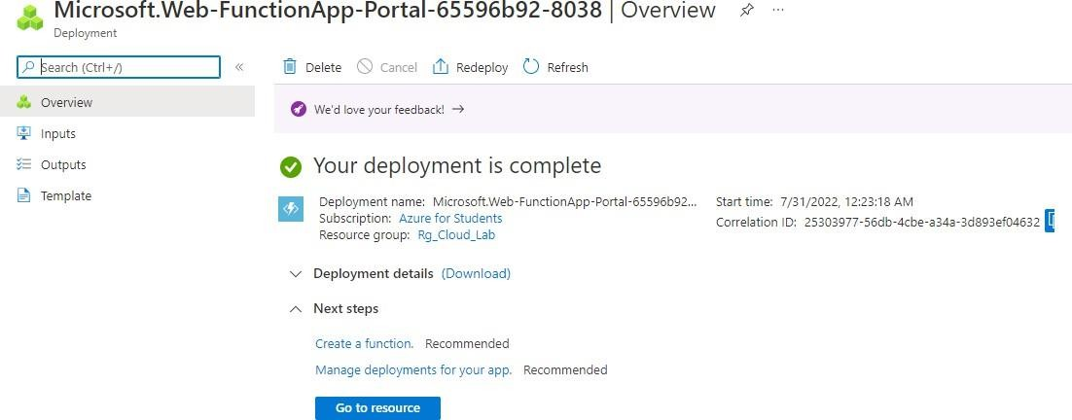

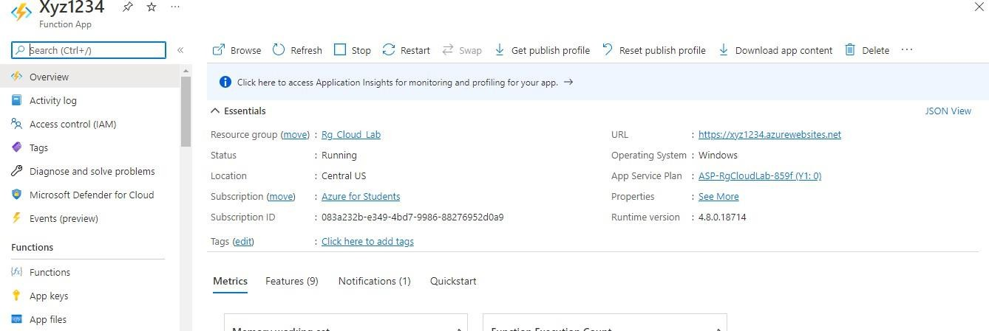

**Create New project in Visual Studio:**

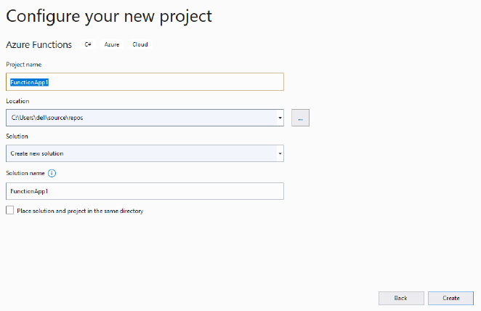

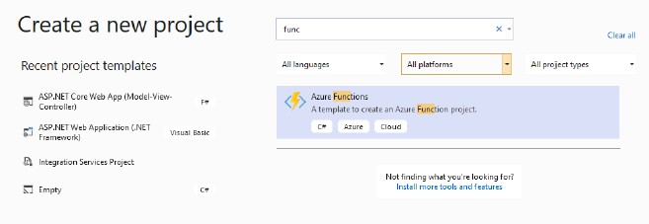

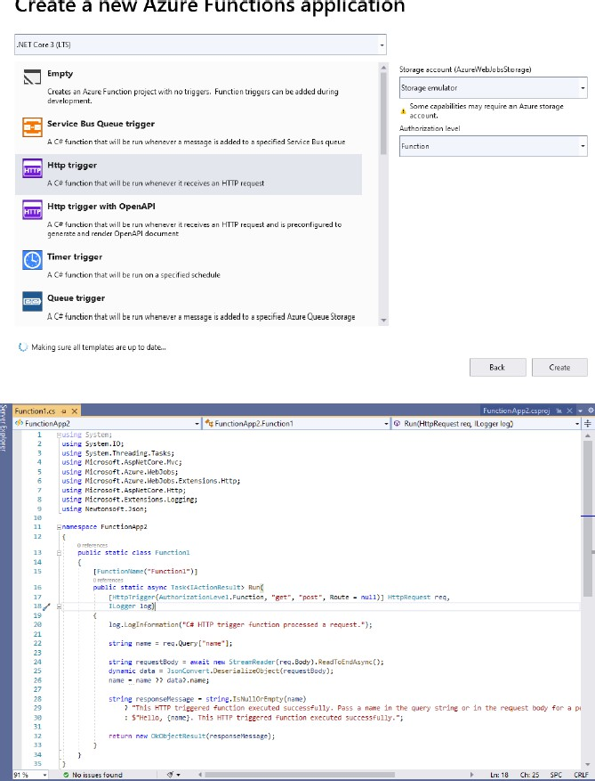

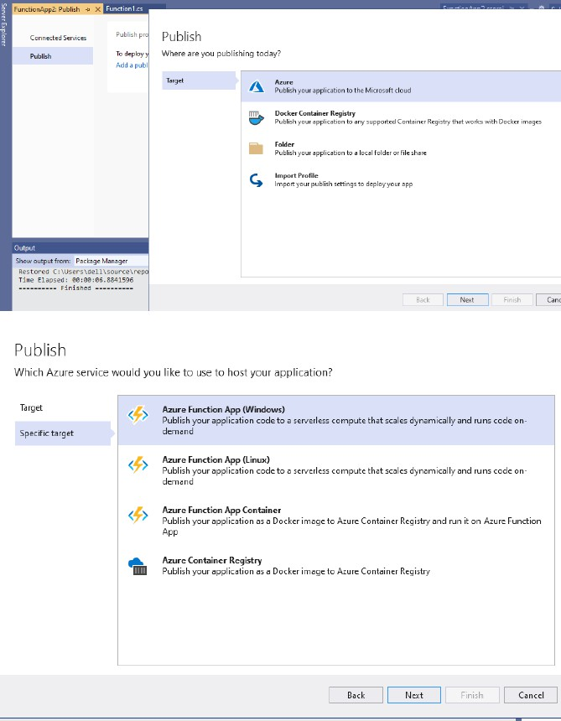



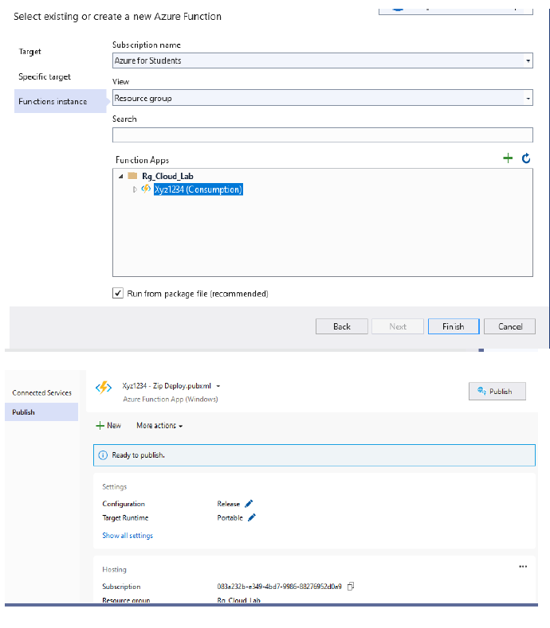

**Lab 9- Creating a Microsoft Azure SQL Database.**

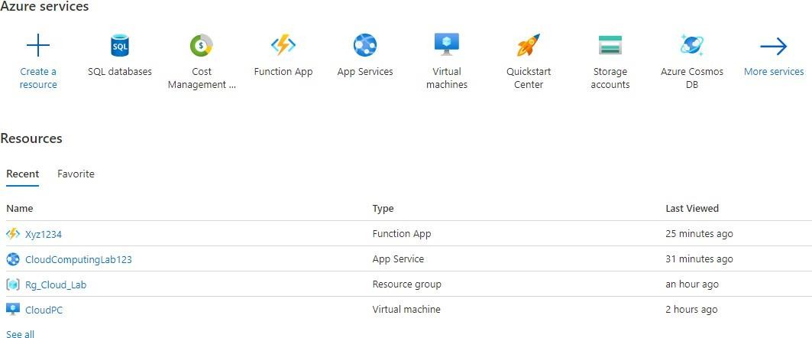

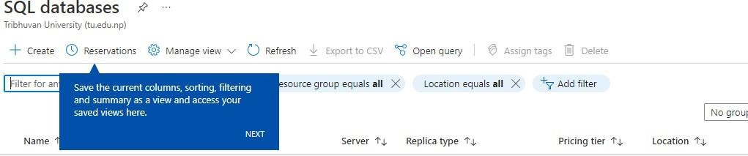

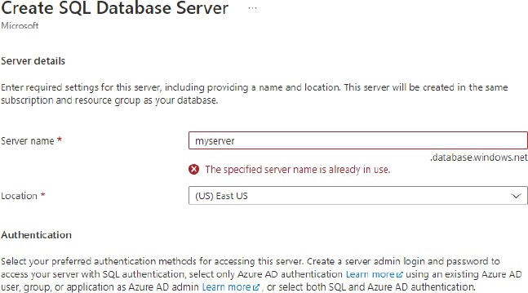

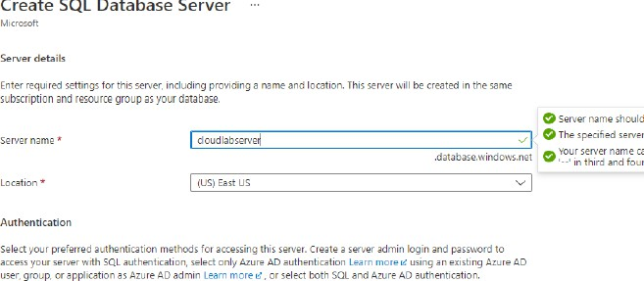

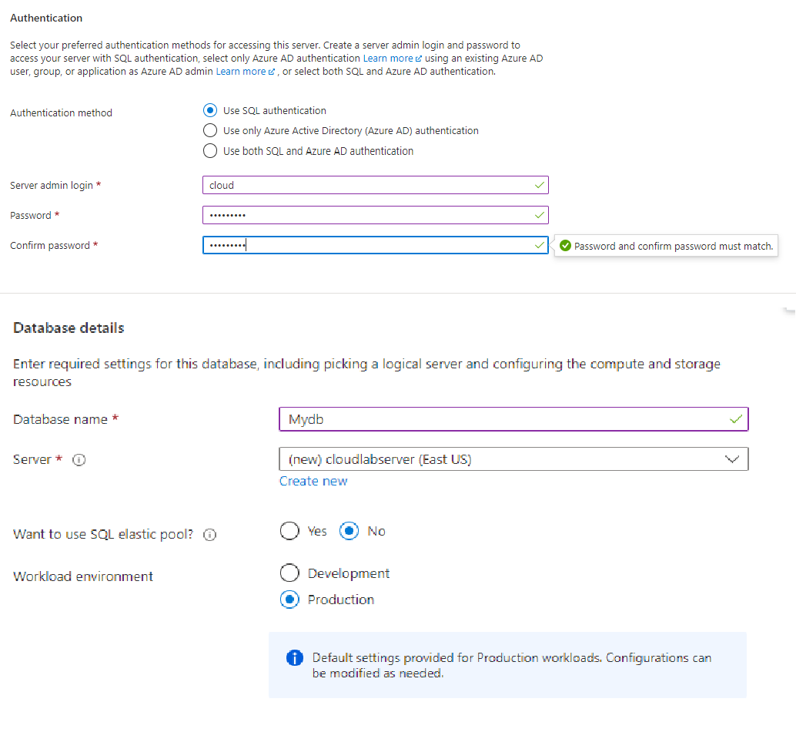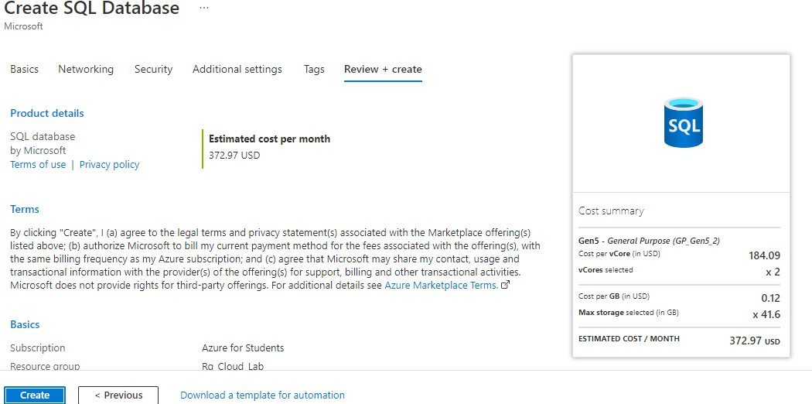

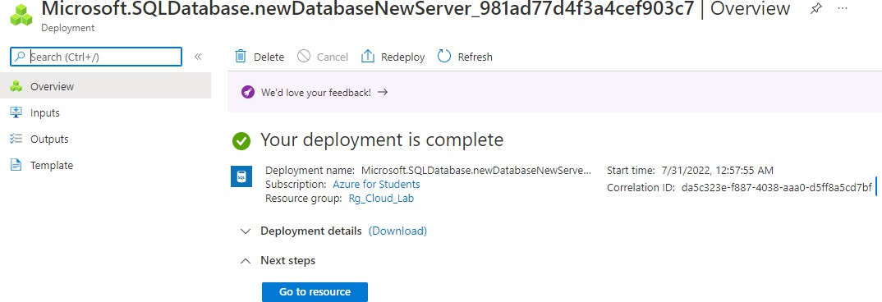

**Lab 10- Manage and control your cloud costs with Azure Cost Management.**

1. Create one management group and assign subscriptions to it, if you haven't already. 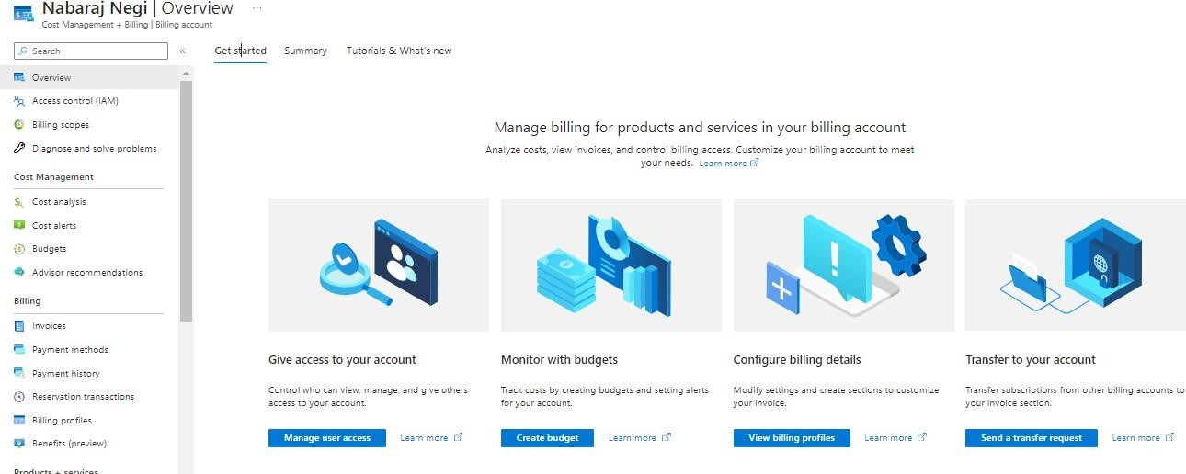
2. In cost analysis, set the scope to your management group and select this management group**.**

